Submission form:

Proposals for the Smoked Tobacco Regulatory Regime

Consultation questions
The Ministry of Health is seeking comments on the following.

Regulatory proposal 1a: Number of smoked tobacco retail premises and their distribution across Aotearoa
This section focusses on how stores that sell tobacco products will be spread across the country. In this section you can tell us if there’s anything you think we should know about how areas should be defined, how many stores should be in each area, and anything important about your area.
This proposal relates to the written notice under section 20M of the Act to set a maximum number of retail premises in areas of New Zealand. Currently there are around 6,000 retailers of smoked tobacco products in Aotearoa. The recent changes to the Act mean that no more than 600 approved retail premises will be permitted to sell smoked tobacco products across the country. We propose that New Zealand be divided into areas based on whether they are urban or rural.
We have suggested an example scenario for smoked tobacco retail premises summarised by region. It is likely that the final distribution will need to be adjusted to take into account feedback from consultation, so this is a starting point for discussion only.
    - Do you agree with dividing Aotearoa into areas and having a separate maximum number of smoked tobacco retail premises for each one?
☒ Yes
☐ No
    - Do you agree with the concept that urban and rural areas should be treated differently?
☒ Yes
☐ No
If you have any comments on how we have defined rural and urban, or how the geographic nature of the area required by the Act should be taken into account, write them here.
Yes, however, we have concerns about how the rural allocation is approached. More details of this concern to follow.
    - Do you agree with our suggested allocation scenario, as described in Table 1 of the consultation document and the supplementary maps we have produced?
☒ Yes
☐ No
If not, how else could you determine the maximum number of retail premises for each area, bearing in mind the Act allows for a maximum of 600 retail premises?
We agree with this in principle. We do however have the following recommendations.
Key recommendations:
- Rural areas need more careful allocation of where retailers may be located. We have noticed the indicative teardrops being placed in areas where no current retailer exists (no current tobacco retailer but in some case no retailer of any sort anywhere nearby). We recommend that that no retailer should be proposed where there were none previously. If people who live rurally have already been traveling to access tobacco, then making a retailer more accessible to them will undermine the intent of the bill.
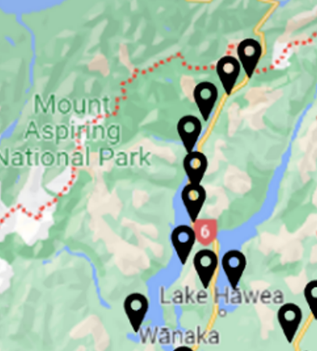 | This is an example from the Mount Aspiring National Park in the Otago Southland Region of indicative teardrops being placed in an area which is predominately a national park with only a few farms. No current tobacco retailers exist here.
 | This section in the Tairawhiti region likewise represents an area leading to a Te Urewera National Park with no current tobacco retailers.
 |  | Again, in the Whangamōmona area in Taranaki, no current tobacco retailers.
- Consideration must be given regarding retailer density in urban areas, particularly in neighbourhoods of higher deprivation where there is strong research evidence that greater access to tobacco facilitates youth smoking uptake, may impede cessation, and could entrench smoking-related health inequities¹.
- We also suggest that outlet numbers be reassessed annually, with the maximum number reduced each year as smoking prevalence decreases.
References for this question
1. Marsh, L., Vaneckova, P., Robertson, L., Johnson, T. O., Doscher, C., Raskind, I. G., ... & Henriksen, L. (2021). Association between density and proximity of tobacco retail outlets with smoking: a systematic review of youth studies. Health & Place, 67, 102275.
    - We are interested in understanding the needs of different areas of Aotearoa. What is your area?
☒ | Northland (Te Tai Tokerau) | ☒ | Manawatū/Whanganui
☒ | Auckland (Tāmaki Makaurau) | ☒ | Wairarapa/Wellington (Te Whanganui-a-Tara)
☒ | Waikato | ☒ | Nelson/Marlborough (Whakatū/Te Tauihu-o-te-waka)
☒ | Bay of Plenty (Te Moana a Toi-te-Huatahi) | ☒ | Tasman/West Coast (Te Tai o Aorere/Te Tai Poutini)
☒ | Tairāwhiti/Hawkes Bay (Te Matau-a-Māui) | ☒ | Canterbury/Chatham Islands (Waitaha/Wharekauri/Rēkohu)
☒ | Taranaki | ☒ | Otago/Southland (Ōtākou/Murihiku)
☐ | Other/I am not in New Zealand (please specify):
 | Click or tap here to enter text. | We represent the entire country.

Regulatory proposal 1b: Minimum requirements for approval as a smoked tobacco retailer
This section focusses on minimum requirements for selling smoked tobacco products. In this section you can tell us about who should be allowed to sell and what type of systems you think they should have.
This proposal relates to key criteria under 20I and regulation making powers under 82A of the Act to require the retailer to meet certain criteria before they can be approved.
The Director-General of Health must be satisfied that retail premises are run by people who are ‘fit and proper’. Further requirements that need to be met can be set in regulations for security, training, delivery, other business systems, and other relevant criteria. We have proposed some requirements which are intended to ensure that the retail scheme works as intended.
    - Do you agree with the proposed requirements for a ‘fit and proper’ person in Appendix 2 of the consultation document?
☒ Yes
☐ No
If you have any comments on the proposed requirements for a ‘fit and proper person, please write them here.
Cancer Society fully support the proposed requirements for a ‘fit and proper person’ and acknowledge the importance for tobacco retailers to be responsible and held accountable for owning a tobacco retailer licence.

Key Recommendations:
- We suggest tobacco licenses are treated in the same way as a duty manager is regarded under alcohol sales license legislation. A licensee would be responsible for all tobacco sales at the store and must be on site at all times.
- We recommend that a retailer who loses their licence should not be able to apply for another license for a different or new store. We also propose that if the proprietor owns more than one licenced store and they lose one of their licences that all their licences be revoked. Any breaches must result in immediate loss of license.
- Other infringements associated with the person’s role as a retailer (aside from tobacco legislation) should also be considered when assessing their status as ‘fit and proper person’. For example, if that retailer has previously been found in breach of gambling sales or alcohol sales.
- The tobacco license should not be transferable. If the licensed store is sold, the license should not be part of the sale but must be applied for separately by the new owners with no guarantee it will be approved.
- Smokefree Enforcement Officers should be consulted when assessing an applicant for specific “fit and proper” criteria. This measure should be specifically included in the regulations and accounted for in the cost recovery of the application fees.
- The cost for assessing license applications, dealing with complaints, and checking if the applicant meets the ‘fit and proper person’ requirements must be covered by the fees as part of a cost recovery approach.
    - Do you agree with the minimum requirements we have proposed for security systems, training, sales systems, delivery systems and other business systems?
☒ Yes
☐ No
Do you have any other suggestions?
Cancer Society fully support the proposed minimum requirements and has the following recommendations for improving them.
Site Visits by Smokefree Enforcement Officers
Regarding retail premises being “a fixed permanent structure and appropriate premises” - We understand this wording was also used in the regulations for Specialist Vape Retailers (SVR), from the Smokefree Environments and Regulated Products (Vaping) Amendment Bill. However, as site visits by Smokefree Enforcement Officers were not stipulated in the regulations there was no capacity afforded for Smokefree Enforcement Officers to carry these out. We know of SVRs who provided photos in their application process to look like they were meeting the requirements of being a fixed permanent structure but were actually temporary structures within another store. Smokefree Enforcement Officers had to wait until there was an official complaint before they were able to raise this issue.
Therefore, the Cancer Society recommends that tobacco license applicants are required to have a physical site visit by a Smokefree Enforcement Officer to approve the suitability of the applicant’s retail space. The Smokefree Enforcement Officers play a crucial role in assessing applications and thus need to be adequately resourced to support their capacity. This measure will need to be accounted for in fees as part of a cost recovery approach.
Training
Cancer Society would like more specific guidelines on the minimum requirements for training, particularly who will develop and deliver the training, who will evaluate it, the frequency of training, and how often the training curriculum is updated to reflect new research.
Consideration should be given to including this measure in the proposed fees to ensure training is of high standard and independent of the tobacco industry to avoid conflict of interest (for example educational programmes run by alcohol companies, i.e. the Smashed programme or the training regime run in relation to Gaming venues). We recommend it is developed by Ministry of Health (MoH) and that costs to undertake training are paid for by the applicant.
We also recommend there be a process for tobacco retailers to be tested once they have had training to assess their knowledge of tobacco products, cessation referral processes, and harms of smoking. This training should also include requirements to provide contact information of cessation providers (e.g., details of Quitline and local stop smoking services) with every purchase; this must be subject to monitoring.
Sales systems
All tobacco retailers should provide monthly sales data that documents sales for each brand, brand variant, and the sales price. This information should be supplied in using an electronic template developed by the MoH to assist with sales monitoring by outlet and region. This information should be verified by an independent data company and subject to regular audit at the retailer’s expense. The ability to provide this data should be a criterion used to assess the suitability of applicants who seek to sell smoked tobacco products. The level of sales across outlets should be a factor used to assess license renewal (i.e., once sales fall below a threshold level, the license would not be renewed).
Funding of Business-related criteria
We recommend transparency of the funding for training, security (e.g. fog cannons), sales systems, etc. to prevent tobacco industry interference. We recognise that it is important for tobacco retailers to keep their staff safe, particularly given ram raids and other recent incidents.
We recommend that the government considers a retailer’s ability to fund the installation of minimum-security requirements when considering licensing permits.
Tobacco companies should not be permitted to fund retailers' minimum-security requirements. Any evidence of direct or indirect tobacco industry funding should automatically lead to the revocation of a permit.
We recommend caution before the government considers providing any grants to retailers to install minimum security requirements as this could incentivise some retailers to want to continue to sell tobacco.

Regulatory proposal 1c: Approval processes and decision-making criteria
This section focusses on the retail application process for smoked tobacco retailers. The Act requires that the Director-General determine and publish a process for applications. We are seeking feedback on 2 main parts: firstly, how the application process will be run, and secondly how we will compare applications against each other if there are too many applicants for an area. Here you can tell us what you think is important to consider. You can find more details on this proposal in the consultation document.
    - Do you agree with the proposed application process?
☒ Yes
☐ No
    - Are there any aspects that need to be clearer?
The Cancer Society would like point four of the ‘Retail application process’ to be amended so the Director-General is legally required to seek information from Smokefree Enforcement Officers to check information through a site visit. This ensures tobacco retailers are fulfilling the requirements to sell tobacco set out by the Director-General.
    - If you have any changes or additions to the criteria we have proposed, please write them here.
As above with further recommendations outlined below.
Consultation with local Smokefree Enforcement Officers
The Cancer Society recommends that all applications are reviewed by Smokefree Enforcement Officers. We recommend they are consulted on the premise history regarding any complaints, compliance breaches, infringements, and prosecutions. The Smokefree Enforcement Officers should also undertake a site visit to verify the verity of the application. Local Smokefree Enforcement Officers will be able to ensure others are not presenting themselves as applicants and effectively “fronting” for people who operate the store and are unable to apply because they do not meet specific “fit and proper” criteria. The costs associated with site visits and the provision of this information must be covered by application fees making it a true cost recovery service. The capacity of the Smokefree Enforcement Officer work force will likely need to be increased. We recommend the Ministry consult current Smokefree Enforcement Officers to work out what extra resources will be required.
Smoked tobacco retailers as specialist R18 stores
Ideally the Cancer Society would prefer tobacco to be sold only in R18 stores to make it less accessible and further denormalise tobacco.
Residential dwellings attached to retailers
For further safety and security, Cancer Society recommends SVRs and Smoked Tobacco Retailers should not be attached to a residential dwelling. This could lead to an increased risk of the home being targeted in a robbery.
Location of retailers
Smoked Tobacco Retailers should not be approved in areas that currently do not have any tobacco retailers, as this would undermine the intent of the Act. The Cancer Society recommends working with local Smokefree Enforcement Officers to ascertain where tobacco retailers are currently located. To this point maps were developed which will assist with this (link to maps of existing retailers here for static and here for a dynamic map).
Community complaints process
We recommend establishing a process that allows community members to register complaints about smoked tobacco retailers. Smokefree Enforcement Officers can assess and investigate these complaints and, depending on their assessment, upheld complaints should lead to the loss of a license to sell smoked tobacco products.
Regulation breaches
The Cancer Society recommends including within the regulations a provision to revoke a license if any breach of the regulations is identified (e.g. as a result of a complaint or via an enforcement check or compliance operation). Appeals should not be permitted, and the Director-General’s decision should be final. However, as stated, we recommend the Director-General work closely with Smokefree Enforcement Officers.
    - What do you think are the most and least important things to take into account when assessing an application?
The Cancer Society believes that all application criteria for smoked tobacco retailers are crucial to ensure that tobacco products are sold safely. Security, training, proximity, location, compliance, and the nature of business need to be considered at all levels when assessing an application. These criteria need to be the minimum requirements for an approved tobacco retailer.
With regards to the relevancy of the nature of the business, we would recommend specialist R18 tobacco retailers who only sell smoked tobacco products rather than ones that sell other everyday grocery items.
If ranking is required, we suggest weighting as follows:
- Proximity and location e.g., in relation to schools, sports fields, marae and to other STRs.
- Compliance history with SERPA (entity or individuals).
- Store type e.g., specialist store ranks higher than convenience store or bottle store.
- Business-related e.g., security, sales systems, supply chain, and training.
- Range of products e.g., cigar only store may rank higher.

Additional retail questions
    - Do you have any feedback on additional decision-making criteria and processes for selling smoked tobacco products online?
Cancer Society do not support online sales as they will undermine the intent of the Act and may also lead to loopholes making tobacco more available than is intended by the Act. If online sales are permitted, then the Cancer Society strongly advocates:
- That online retailers do not become the default position for tobacco sales. Online retailers should count towards the total number of retailers within each region and should not exceed the maximum number of 600 for the entire country.
- Not allowing online sales where there has not been a physical premise selling tobacco products previously. For example, if someone previously had to travel because there was no nearby physical location selling tobacco products, then being able to have them delivered directly to their home is counter intuitive to the purposes of the Act.
- Online sales should only be permitted in consultation with local Smokefree Enforcement Officers, e.g. if they believed that online sales were necessary as the community had previously been served by tobacco sales from a physical premise.
- A mechanism is put in place to limit the delivery range for online retailers, so they are strictly limited to sell only to the areas that have no access to a physical retailer. This is already possible for online stores which sell their goods in some countries and not others.
- Not allowing sales via on-demand delivery services like Delivery Easy or Uber Eats. Same day delivery from any online retailer should also be prohibited. Likewise, buy now, pay later schemes should also be prohibited for all tobacco and vaping products.
- They must include referral pathways to cessation support.
The Cancer Society has concerns that that current delivery protocols do not protect people from being sold or delivered age restricted products such as tobacco, vapes, or alcohol. We would recommend options to address this be considered.
Limiting sales to underaged and members of the Smokefree generation
Internet sales of commercial tobacco and vaping products to underaged adolescents significantly undermines efforts to protect public health and risks creating a new generation of nicotine users.
Any records of sales to minors as a retail premise should invalidate a person applying to sell tobacco products online.
If online sales are permitted, Cancer Society advocates for stronger age verification checks for online purchases of tobacco products. Substantial evidence has shown that underaged persons can and do acquire tobacco products from online distributors¹. International evidence shows that adolescents under 18 find it easy to circumvent age restrictions². In a large representative sample of 10th and 12th graders in California, Unger et al showed that 32% of those who had tried cigarettes rated the Internet as their most recent source for cigarettes³.
Under section 40 of the Smokefree Environments and Regulated Products Act, it is an offence for a person to sell a notifiable product to a person younger than 18 years or, having sold a notifiable product to a person of any age, to deliver it, or arrange for it to be delivered, to a person younger than 18 years⁴. However, most tobacco sales websites simply require the consumer to click a button to verify that they are over 18, or to enter their birth date and click on a button to verify this date.
For example, we had only to click on a button to say we were over 18 to see these 2 images below.
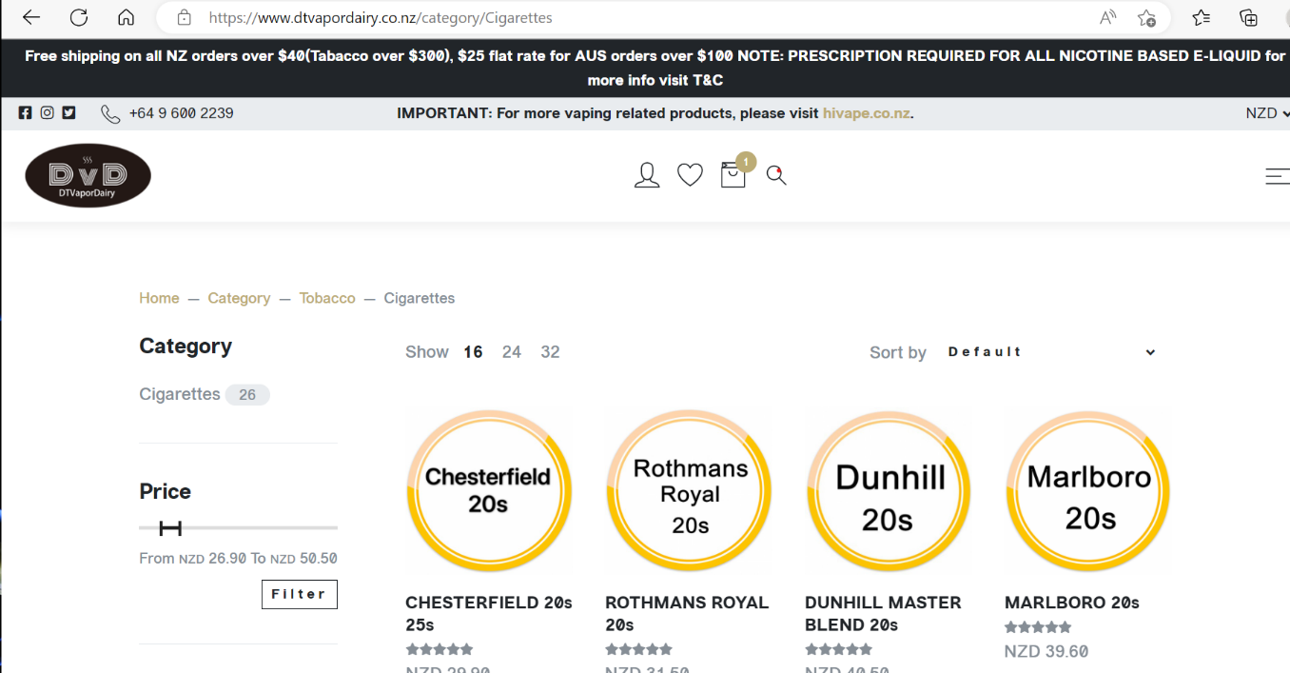

It is easy for anyone under age 18 to bypass the online age restrictions by simply lying about their age as generally no proof of age is required. To purchase they can easily use someone else’s debit or credit card. We would encourage MoH to incorporate a more robust I.D verification process, for example RealMe account, or an equivalent, requirements could be considered to validate a proof of age.
The Public Health Law Centre in Minnesota USA highlights the 2010 Prevent All Cigarette Trafficking Act (PACT Act) as having played an important role in regulating internet sales of commercial tobacco⁵. Cancer Society would encourage MoH to look into this example as a potential method to follow.
References for this question
1. Williams, R. S., Derrick, J., & Phillips, K. J. (2017). Cigarette sales to minors via the internet: how the story has changed in the wake of federal regulation. Tobacco control, 26(4), 415-420. https://www.ncbi.nlm.nih.gov/pmc/articles/PMC5236008/
2. Williams, R., Ribisl, K., & Jo, C. (2011). Response to Advance Notice of Proposed Rulemaking on Non-Face to-Face Sale and Distribution of Tobacco Products and Advertising, Promotion, and Marketing of Tobacco Products. Chapel Hill, NC: University of North Carolina at Chapel Hill. https://www.regulations.gov/comment/FDA-2011-N-0467-0100
3. Unger, J. B., Rohrbach, L. A., & Ribisl, K. M. (2001). Are adolescents attempting to buy cigarettes on the internet?. Tobacco Control, 10(4), 360-363. https://tobaccocontrol.bmj.com/content/tobaccocontrol/10/4/360.full.pdf
4. Manatū Hauora- Prohibitions and requirements for the sale of notifiable products (2023)
https://www.health.govt.nz/our-work/regulation-health-and-disability-system/regulation-vaping-herbal-smoking-and-smokeless-tobacco-products/information-retailers-and-distributors-notifiable-products/prohibitions-and-requirements-sale-notifiable-products
5. Mitchell Hamlin School of Law :The Public Health Law Centre: Online Sales of E-Cigarettes & Other Tobacco Products (2022) https://www.publichealthlawcenter.org/sites/default/files/resources/Online-Sales-E-Cigarettes-Other-Tobacco-Products.pdf
    - Do you have any feedback on possible support for retailers who are no longer able to sell smoked tobacco products?
We would urge development of robust communications with an adequate lead in time to inform retailers of the upcoming changes and to socialise the intent of the changes, the application process, and the criteria for applying to be a smoked tobacco retailer in Aotearoa.
Retail reduction has been in discussion for over 10 years, businesses have had adequate time to prepare for reduced tobacco sales.
Information about how retailers have become tobacco free in Aotearoa could be shared with current retailers as good practice case studies for how they managed the transition away from selling tobacco products. We would urge retailers to replace tobacco with items their communities need.

Regulatory proposal 2: Approval processes and decision-making criteria
From 1 April 2025 only low nicotine smoked tobacco products will be allowed in Aotearoa. This section focusses on the details of testing and product requirements, application processes as well as product packaging updates needed. You can find more details on this proposal in the consultation document.
    - Do you agree that a suitable testing method may include a method based on WHO SOP4, validated to account for the low nicotine levels prescribed?
☐ Yes
☐ No
The Cancer Society is not best placed to advise on this question and therefore recommends consultation with experts such as WHO Study Group on Tobacco Product Regulation (TobReg) and MoH Technical Advisory Group. However, we acknowledge it is sensible to limit test options to ones that are reputable and independent of the tobacco industry.
With regards to the maximum level of nicotine of being 0.8mg/g tobacco, we suggest the aim should be that all Smoked Tobacco Products have a mean nicotine concentration of 0.4mg/g tobacco but no more than 0.8mg/g tobacco. This would be in line with evidence from research which shows that cigarettes/tobacco with this level of nicotine are most likely to result in reduced smoking and dependence and increased quitting. It may be difficult to write a mean target into regulations, but the policy intent could be communicated. There is international interest in the regulations in New Zealand and other countries will be interested in both the policy intent and the drafting.
    - Do you have any other suggestions for suitable chemical analytical methods?
The Cancer Society is not best placed to advise on this question and therefore recommends consultation with experts such as WHO (TobReg) and MoH Technical Advisory Group.
    - Do you agree with the proposal that the main packaging change should be to allow the words ’very low nicotine’ on qualifying smoked tobacco products?
☐ Yes
☒ No
If not, why not?
The Cancer Society is ambivalent about this measure as it risks playing into misperceptions that nicotine causes the harm in smoking, and some people may believe very low nicotine makes smoking less dangerous. We question the benefit of having these words on the labels, especially as all products available will be very low nicotine. More should be done to ensure people who smoke understand that the carcinogens in smoked tobacco remain in very low nicotine cigarettes.
    - Do you agree with the proposal to require an insert in smoked tobacco product packs?
☒ Yes
☐ No
If you have any additional feedback on smoked tobacco packaging, please comment here.
Yes. We commend the idea to introduce inserts informing people of upcoming changes and encouraging them to become Smokefree.
    - Do you agree with the product application requirements?
☒ Yes
☐ No
    - If you have further comments on product application requirements, please write them here
No comments.
    - Do you agree with the proposed requirements for temporary approvals?
☐ Yes
☒ No
    - If you have further any comments on the proposed requirements for temporary approvals, please write them here.
Cancer Society has concerns that this measure will create a loophole for the tobacco industry.

Regulatory Proposal 3: Fees
This section focusses on fees for applications, registrations and product approvals. You can find more details on this proposal in the consultation document.
    - Do you agree that Manatū Hauora should charge for these processes?
☒ Yes
☐ No
What processes do you suggest we charge for?
The Cancer Society agrees there should be fees for these processes; however, all fees must reflect a full cost recovery approach. We would recommend that:
- All applications are reviewed by local Smokefree Enforcement Officers. The costs associated with site visits and the provision of this information must be covered by application fees, making it a true cost recovery service. The capacity of the Smokefree Enforcement Officer work force will likely need to be increased. We recommend the Ministry consult current Smokefree Enforcement Officers to work out what extra resources will be required.
- Capacity and time required from Ministry of Health staff, Te Whatu Ora staff, and Smokefree Enforcement Officers to assess applications (including consultation on the premise history regarding any complaints, compliance breaches, infringements, and prosecutions), site visits, controlled purchase operations, and analysis of sales data. We note the fees will also be required to cover any other tasks necessary to ensure a rigorous application review process.
We also urge the consideration of costs for a product stewardship scheme to better manage the environmental impacts (e.g. clean-up costs for littered butts/packaging) which are currently falling to local councils, members of the public, and charities rather than the manufacturers of the tobacco product waste. This measure should also be a consideration for vape product waste.
    - Do you agree with the level of each of the fees?
☐ Yes
☒ No
If not, how much do you suggest we charge?
All fees must reflect the full cost of recovery. We believe the annual $80 registration fee is likely too low to meet a cost-recovery approach. Not just for the application process costs, but also for monitoring and compliance testing, funding for legal advice, support in the event of legal challenges and costs for vetting applications. As highlighted previously, it must cover costs associated with checking with local Smokefree Enforcement Officers to verify if there have been any complaints or infringements, as well as site visits to ensure it is a full cost recovery process.
We note that fees for alcohol licensing are significantly higher. We feel that these better reflect the full cost of recovery and set a useful the precedent for smoked tobacco substances.
    - Do you agree with our cost recovery approach?
☒ Yes
☐ No
If not, what approach do you suggest we use?
Yes, however, as stated above it must truly reflect full cost recovery. It must be comprehensive and cover all aspects of registration/approval processes including monitoring and compliance costs, legal support. We would also recommend a levy to cover additional societal costs, such as environmental impacts. As stated above, consideration should be given to including fees to ensure training is of high standard and independent of the tobacco industry to avoid conflict of interest (for example educational programmes run by alcohol companies, i.e. the Smashed programme, and Gaming Industry training).

Regulatory proposal 4: Notification requirements
This section is about the process for distributors of smoked tobacco products and retailers of notifiable products to tell the Director-General about their business. You can find more details on this proposal in the consultation document.
    - Do you agree with the proposal that distributors and general retails be required to re-register annually?
☒ Yes
☐ No
If you have any further comments (including how frequently registration should be required) please write them here.
Yes, we agree with the proposal that distributors and general retailers be required to re-register annually. This is sufficient and reasonable timing to make sure that market information is kept up to date. It should include a re-assessment of distributors and retailers and an assessment of compliance that all criteria for approval are still met.

Regulatory proposal 5: Youth vaping
Youth vaping rates are currently increasing. We propose extending vaping packaging and product restrictions to further improve product safety and reduce the appeal of these products to young people, specifically through restricting flavour names and introducing product safety requirements for single use vaping products. You can find more details on this proposal in the consultation document.
    - Do you agree with the proposal to restrict the flavour names of vaping products to minimise their appeal to youth?
☒ Yes
☐ No
If not, why not? If you agree, which names do you think should be excluded or replaced on the example e-liquid flavour wheel set out in the consultation document?
The context for any discussion on youth vaping, also needs to recognise that vaping is intimately connected with smoking, and that vaping is a helpful tool for some people who smoke to become Smokefree.
Whatever the policy settings are for youth vaping, it is important that the policy framework ensures that people who smoke understand that:

- Vaping is less harmful than smoking.
- Vaping helps some people quit smoking.
- The best thing that people who smoke can do for their health is be smokefree.
We are aware of people who used to smoke who have used vaping to quit, this will result in reduced cancer risk. Vaping has the potential to help people who smoke to quit smoking and contribute to New Zealand’s Smokefree 2025 goal provided people are supported to use vaping appropriately to become Smokefree.
There is concern that some people who smoke will be reluctant to switch to vaping if they only hear about the harms of youth vaping. We’re aware of previous research by Te Hiringa Hauora which highlighted 28% of respondents felt that e-cigarettes were as harmful, or more harmful, than tobacco cigarettes. (see here)
We also acknowledge that its crucial to communicate to our youth that:
- Vaping is not harmless.
- Vaping is not for non-smokers.
- Vaping is not for children or young people.
- It’s best for your health to be Vapefree.

We do not believe these statements about vaping are particularly in dispute. See for example Vaping Facts here.
Research shows that people who do not smoke tobacco but use e-cigarettes are around three times more likely than those who avoid e-cigarettes to start smoking standard combustible cigarettes and continue to use them regularly². We support more research on the extent of the gateway effect from vaping to smoking, as well as research on other harms of vaping (e.g., the extent to which young people are starting to consume other via their vapes). Some of the current research is based on correlation, rather than causation. As vaping products are still relatively new, there is not as much evidence about the long-term harms as exists for tobacco.
As there is evidence of a gateway impact (from youth vaping to smoking), addressing youth vaping is an important aspect of the Smokefree 2025 goal. With higher numbers of 10- to 15-year-old rangatahi vaping daily, this is important for the Māori Auahi Kore kaupapa¹.
The existing regulations are not strong enough to curb the rising rates of youth vaping¹, and so it is necessary the Government take measures to protect young people who have never smoked from taking up vaping. The measures we are proposing are aimed at striking the right balance of making vapes less appealing, less addictive, less affordable, and less available to reduce vaping prevalence among young people – while continuing to keep vaping sufficiently available as an option to help people who smoke to quit.

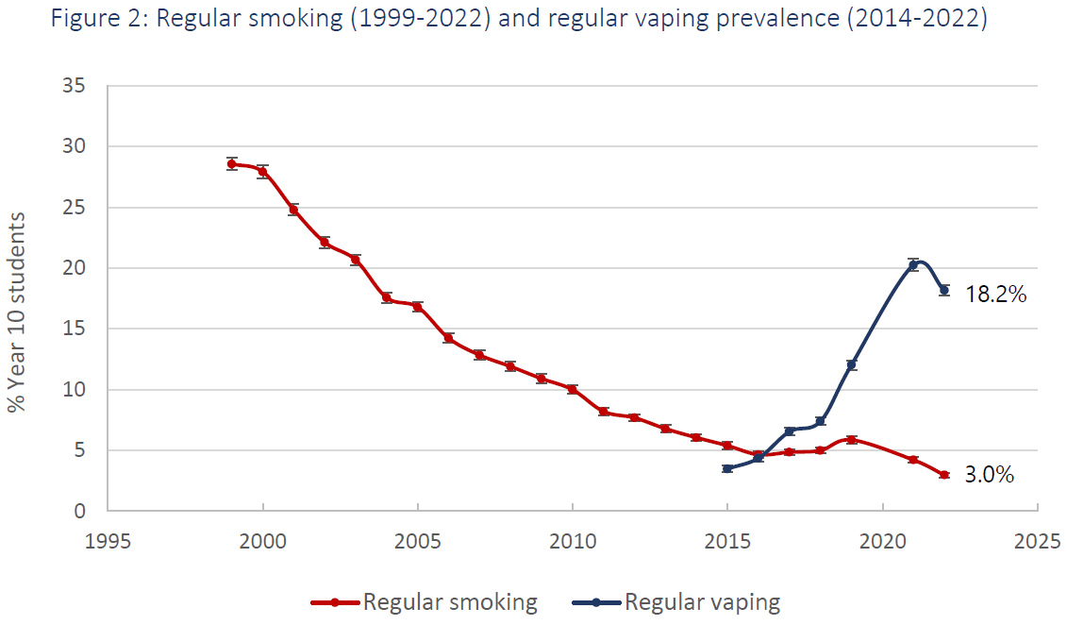
Figure: Prevalence of regular smoking and regular vaping from ASH Year 10 Snapshot Survey 2022.
“Regular” use is defined as participants that report smoking or vaping either daily, weekly, or monthly.
We believe reducing the aesthetic appeal of vapes to young people, including removing the use of appealing flavour names that specifically target youth, is an important aspect of improving the regulations. For this reason, we agree with the proposal to restrict the flavour names of vaping products to minimise their appeal to young people.
Key Recommendations
- The name on a vaping substance or its packaging should be restricted to the description of the product’s flavour.
- Only one name should be used, not a combination of names or other descriptors, from a prescribed e-liquid flavour wheel. No flavour combinations or creative names should be permitted.
  - For example, Generic Vape Retailers (GVRs) are currently restricted to selling three flavours (Tobacco, Mint, and Menthol); however, many products are labelled with extra descriptors specifically to increase their appeal. e.g. the Vuse brand (owned by British American Tobacco) has Crisp Mint, Creamy Mint, and Golden Tobacco. Likewise, the other brand commonly sold in GVRs, alt, has Menthol Ice, Aqua Mint, and Gold Tobacco. All of which are designed to increase appeal to youth.
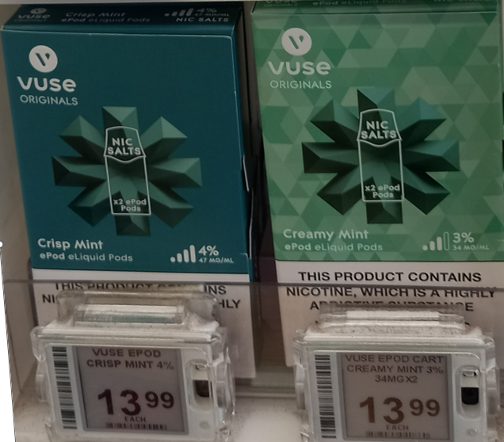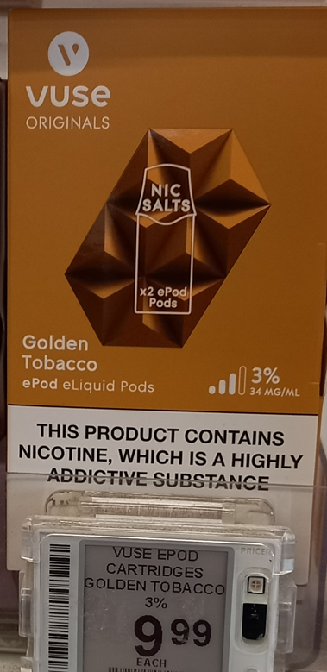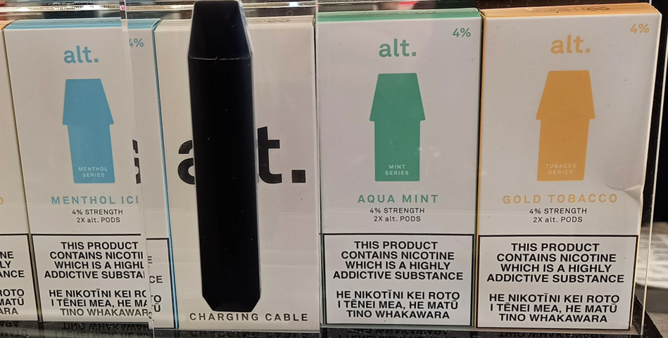
Images taken from local supermarket, Southland, February 2023
- The prescribed flavour wheel includes many flavours that appear to target young people. We believe current flavours directly appeal to young people, with flavours such as Candy, Other Sweets, Dessert, and Alcohol. While we can see the benefit of a range of flavours to ensure that vaping remains more appealing to a person who smokes than combustibles, the Cancer Society is not opposed to restrictions on flavours to protect young people. We would recommend also removing the ‘other’ vape flavour category to prevent an exploitable loophole.

Further Recommendations:
- Quit service staff should be specifically consulted on flavour choices as their experience with helping people to quit combustible tobacco cigarettes should be balanced with the need to reduce vape product flavours that are associated with targeting youth.
- We recommend a periodic review of the vaping regulatory environment occurs to ensure settings sufficiently protect rangatahi (for example, it could be appropriate to further reduce GVRs but acknowledge this would need to be accomplished with a legislative amendment).
- We also recommend not allowing the use of Te Reo e.g., vape flavours ‘aporo’, ‘kūmara’ or ‘kawakawa’. as this is a form of cultural misappropriation.
References for this question
1. Action for Smokefree 2025 (ASH). 2022. ASH Year 10 Snapshot Survey 2022 Topline - Youth smoking and vaping. Available from: http://ash.org.nz
2. Baenziger, O. N., Ford, L., Yazidjoglou, A., Joshy, G., & Banks, E. (2021). E-cigarette use and combustible tobacco cigarette smoking uptake among non-smokers, including relapse in former smokers: umbrella review, systematic review and meta-analysis. BMJ open, 11(3), e045603. Available from: https://www.ncbi.nlm.nih.gov/pubmed/33785493
3. Personal communication between a health promoter and young person aged 21, 12 February 2023, Ōtepoti Dunedin
    - Do you agree with the proposal to extend product safety requirements for disposable vaping products?
☒ Yes
☐ No
If you have further comments on the proposal to extend product safety requirements for disposable vaping products, please write them here.
Yes, we agree with the proposal to extend product safety requirements for disposable vaping products as this will make vaping products less available, less addictive, and less affordable to youth. Especially removeable replaceable batteries.

- User safety mechanisms: We suggest inserting a child-safety lock on all vaping devices.
- Removeable/replaceable batteries: We strongly endorse this requirement that all devices have removeable batteries. This can prevent the risk of battery failure/explosion or other vape-related injuries¹, which is on the rise in New Zealand² and in many other countries. Vaping devices are often disposed into rubbish bins where the batteries pose a dangerous risk for fires in public waste/recycling areas or on rubbish trucks³. For instance, see a recent example of a fire caused by vape products in Waikato⁴.
Requiring removable batteries on all vaping devices would eliminate disposable vapes and other inexpensive products currently sold on the market. This would go some way to help protect rangatahi from consuming these products, as affordable short-term-use vape devices act as a gateway for long-term behaviours⁵. Since people who smoke will need vaping devices that operate for weeks or months as part of their cessation plan, disposable vapes that only function over a much shorter term might be less useful in supporting a transition from smoking.
- Substance container labelling: We support this measure.
- Nicotine concentrations in non-refillable products: Cancer Society supports this measure but strongly recommends a lower minimum limit of 20 mg/mL. to bring in line with European Union (EU) standards. Making such a reduction allows people to choose a lower concentration of nicotine in re-useable devices, but single-use devices would have a fixed nicotine concentration that is generally close to the maximum permitted.
We request clarification on the regulation’s proposed level of 35mg/mL. According to the EU, a concentration of 20mg/mL has been shown to be comparable to the dosage of a standard cigarette during the time needed to smoke such a cigarette⁶. To prevent the risks linked to nicotine use, a maximum nicotine dose should be set to 20mg/mL, not 35mg/mL. We echo a quote from the British American Tobacco Company, who stated in 1959: “To lower nicotine too much might end up destroying the nicotine habit in a large number of consumers and prevent it from ever being acquired by new smokers.” ⁷.
Furthermore, we propose nicotine levels be displayed on product labels in mg/mL, including single-use products, as a percentage figure for nicotine/nicotine salt concentration is not sufficient.
- Serial/batch numbers: We support this measure.
Further Recommendations:
We propose the following additional product safety requirements to address concerns relating to single-use vaping products:
Fund support for quitting vaping:
Stop Smoking Services need to be fully funded and resourced to extend their support to those who wish to stop vaping (regardless of whether they smoke tobacco or not). We are particularly concerned about under 18 years old, where there is some evidence that vaping is a gateway to smoking.
Plain packaging and health warnings:
We recommend implementing plain packaging on all vape products (devices and vaping “pods”). Removing colourful designs and cartoons would make these products less appealing to young people⁸. We also recommend health warning labels clearly stated on all vaping products (devices and “pods”). These changes would help reduce the uptake of vaping among young people⁹.
Our communities (e.g., quit coaches) have also told us they want stronger messaging about the harms of vaping, including on packaging, in stores, and on the Ministry of Health website.
It will be a challenge to land on the correct messaging. For example, the messaging on the Vaping Facts website is “Vaping is not harmless, but it is much less harmful than smoking. Vaping can help some people quit smoking”. However, we understand that the phrase “less harmful” can cause confusion among the public and young people.
Youth and smoking cessation experts should be involved in the process of building safety awareness for vaping products. It’s important this message finds the right balance in communicating to those who smoke that vaping is better than smoking, and communicating to everyone else that vaping is not harmless. This can include on-pack messages, as they are not obvious and can influence the uptake of vaping products as stated in the plain packaging recommendation.
End sale of disposable vapes:
Considering proposal b. (Removeable/replaceable batteries), we recommend ending the sale of disposable vapes. Doing so would reduce young people’s ability to afford vaping products. We do not think the availability of disposable vapes is important as part of the role of vaping as a quit option. There is also support from vaping experts to ban disposable vapes as they see the negative impacts among young people. Shosha spokesperson, Nabhik Gupta, stated that lower costing disposable vapes are exposing non-smoking youth to nicotine addiction and negative health complications, and because of this we should have new regulations that prevent these products from being imported and sold¹⁰.
Additionally, consideration should be made to remove products with 6ml or less e-liquid, as these products do not support people who smoke trying to quit and are useless for smoking cessation.
Furthermore, ending sales of disposable vapes would reduce the pollution of toxic chemicals, heavy metals, flammable ion batteries, and microplastics that vapes introduce into our waterways and natural environments¹¹.
Promotion measures:
We recommend the Government prohibit sale promotions in-store and online and require that vaping products are not visible from the street. As shown in the image below, vape stores usually have see-through glass windows which showcase vaping products to people on the street. By prohibiting visibility, this will further lessen the appeal of vaping products to young people.
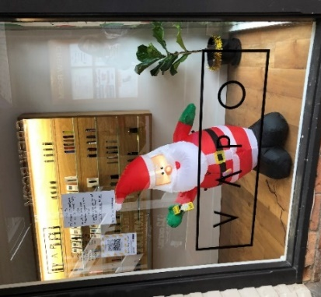
Blaze n Chill, vape store, Wellington CBD, taken 27/12/22 Vapo, Specialist Vape Store, Queenstown, taken 15/12/2020.
Cancer Society Wellington: Mapping Project.
Monitoring and enforcing age restrictions and safety requirements of online and in-person sales:
We further recommend monitoring and better enforcement of age restrictions when purchasing vaping products online and in-person. A study about online marketing of e-cigarettes in New Zealand showed that vendors do not adequately prevent children or young people from accessing these products, nor do they provide sufficient safety information to buyers¹². We propose any requirements for online tobacco sales apply to online vape product sales as well.
Include pricing measures on vaping products if youth vaping rates continue to rise:
We recommend introducing pricing measures on vaping products such as a minimum price or excise tax should youth vaping continue to rise. A study revealed that youth were less likely to purchase e-cigarettes if the product price increased, especially for non-users: this estimated a 10% price increase could cause a 24% reduction among nicotine users, and 45% reduction for non-users of nicotine¹³. We understand tax increases could be a barrier for people who are trying to quit smoking; however, considerations should still be made for minimum prices of vaping products with the continual rise of youth vaping. Funding could be allocated to smoking cessation services to allow vaping products to be subsidised, making vaping products more affordable for those who are trying to quit smoking.
References for this question
1. Quiroga, L., Asif, M., Lagziel, T., Bhat, D., & Caffrey, J. (2019). E-cigarette battery explosions: review of the acute management of the burns and the impact on our population. Cureus, 11(8). https://doi.org/10.7759/cureus.5355
2. Lawrence, M. (2019). Burns, broken glass, and explosions: E-cigarette injuries on the rise in New Zealand. NZ Herald. https://www.nzherald.co.nz/nz/burns-broken-teeth-and-explosions-e-cigarette-injuries-on-the-rise-in-new-zealand/P2TAS7FAE3YXEBS7QMK7ADSYUY/
3. Pourchez, J., Mercier, C., Forest,V. (2022). From smoking to Vaping: a new environmental threat?. The Lancet: Respiratory Medicine, Volume 10, Issue 7, E63-E64. https://doi.org/10.1016/S2213-2600(22)00187-4
4. Stuff - Waikato times. (2023) Vape battery in yellow bin sets recycling truck on fire retrieved Feb 24 2023 from https://www.stuff.co.nz/waikato-times/news/300815570/vape-battery-in-yellow-bin-sets-recycling-truck-on-fire
5. Chapman, S., Bareham, D., & Maziak, W. (2019). The gateway effect of e-cigarettes: reflections on main criticisms. Nicotine and Tobacco Research, 21(5), 695-698. https://doi.org/10.1093/ntr/nty067
6. European Commission. (2014). Directive 2014/40/EU of the European Parliament and of the Council of 3 April 2014 on the approximation of the laws, regulations and administrative provisions of the Member States concerning the manufacture, presentation and sale of tobacco and related products and repealing Directive 2001/37/EC. Off J Eur Union, 127, 1-38. https://eur-lex.europa.eu/legal-content/EN/TXT/PDF/?uri=CELEX:32014L0040
7. British American Tobacco Company, RDW. Complexity of the PA 5A machine and variables pool. Minnesota Trial Exhibit 10,392, State of Minnesota et al v. Phlip Morris, Incl, et al. (1959).
8. Hunt, J. (2023). UK campaigners call for tighter regulations on vapes to match tobacco. The Guardian. UK campaigners call for tighter regulations on vapes to match tobacco | E-cigarettes | The Guardian
9. Shang, C., Huang, J., Chaloupka, F. J., & Emery, S. L. (2018). The impact of flavour, device type and warning messages on youth preferences for electronic nicotine delivery systems: evidence from an online discrete choice experiment. Tobacco control, 27(e2), e152–e159. https://doi.org/10.1136/tobaccocontrol-2017-053754
10. Vaping experts call for product ban. (2022, August 3). SunLive. SunLive - Vaping experts call for product ban - The Bay's News First.
11. Truth Initiative. (2021). A Toxic, Plastic Problem: E-cigarette Waste and the Environment. Washington, DC. https://truthinitiative.org/research-resources/harmful-effects-tobacco/tobacco-and-environment.
12. Gurram N, Thomson G, Wilson N, Hoek J. Electronic cigarette online marketing by New Zealand vendors. The New Zealand Medical Journal. 2019 Nov;132(1506):20-33. PMID: 31778369.
13. Corrigan, J. R., Hackenberry, B. N., Lambert, V. C., Rousu, M. C., Thrasher, J. F., & Hammond, D. (2021). Estimating the price elasticity of demand for JUUL E-cigarettes among teens. Drug and alcohol dependence, 218, 108406. https://doi.org/10.1016/j.drugalcdep.2020.108406
    - Do you agree with the proposal to restrict where specialist vape retailers can be located?
☒ Yes
☐ No
If you have any further comments on where Specialist Vape Retailers are located (including any particular locations that are important to you), please write them here.
Existing Government measures have not curbed the trend of rising youth vaping rates¹. We therefore believe that reducing the overall number of outlets selling vape products is key to making vapes less available to our youth. The number of outlets should be set taking into account the number of outlets needed to support vaping to quit smoking.
The number of vape retailers has been on the rise since the vaping regulations² came into force in late 2020. Across New Zealand, there are currently over 1,204 R18 Specialist Vape Retailers (SVRs)³ selling a vast assortment of flavours, and even more General Vape Retailers (GVRs) selling the 3 restricted flavours. A number of these SVRs are “stores-within-a-store” located inside dairies and convenience stores.
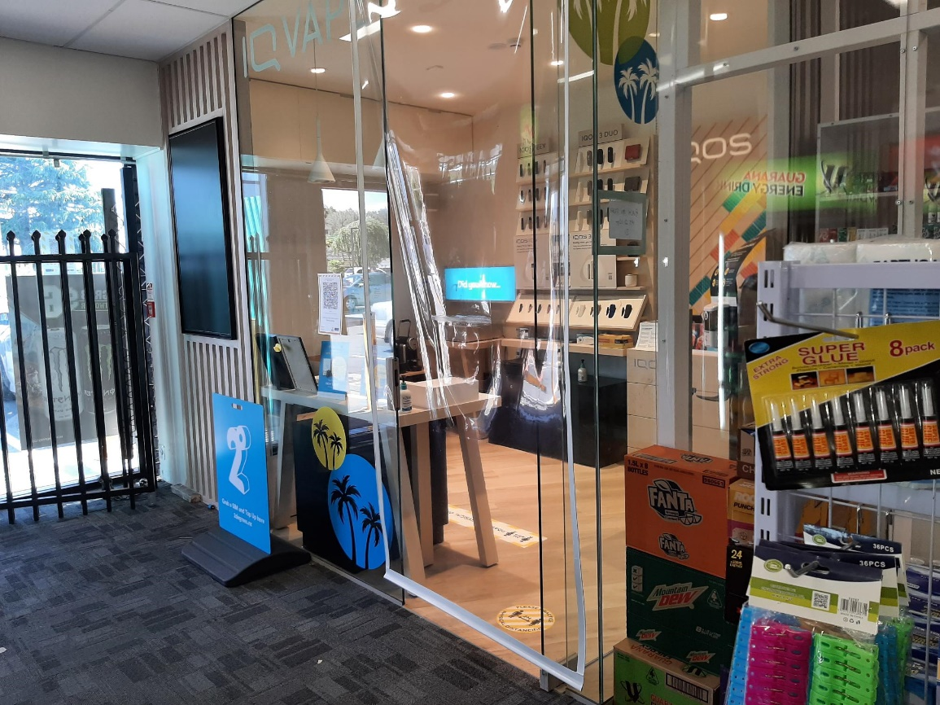
An example of a discounter store with a “stores-within-a-store”.
The positioning of these types of SVRs within other convenience stores increases the density of SVRs within residential neighbourhoods and near schools and is influential in normalising these products to youth who frequent dairies^{4, 5}.
Allowing vape products to be sold across such wide distribution networks means they are as common as other essential everyday items such as bread and milk⁴. We agree that applying proximity restrictions to SVRs is necessary in reducing the accessibility and availability of vape products to our youth.
Key Recommendations
- Set proximity limits that prevent SVRs from operating near schools, ECEs, and other sensitive areas (where vulnerable people gather).
- Set density limits to enable vaping to quit but prevent clustering of SVRs in populated areas as Local Government NZ called for in a recent remit⁶.
- Ideally these limits would also apply to GVRs.
- Consider total vape retailer numbers (SVRs and GVRs combined) across the country similarly to Proposal 1a for tobacco retailers. Restricting the total number of retailers is crucial in ensuring vape products are not overly accessible and “within arm’s reach of desire” taken out of the play book of Coca Cola⁷.
- Enforce age restrictions for online sales similarly to those for tobacco to ensure products are not sold to under 18s.
Further Recommendations
We recommend removing the sale of vape products from generic outlets such as dairies, convenience stores, supermarkets, and petrol stations so that the sale of such products is allowed only at R18 SVRs. Removing these products from generic outlets would help denormalise them by making them less visible to youth.
Vape products are not low-risk, easy to understand consumer products. Purchasers require advice around device type, flavours, nicotine levels, and general use^{8, 9}. Staff in R18 SVRs are more likely to be equipped to assist people who want to use vaping for tobacco cessation than clerks in convenience stores and supermarkets. Moreover, we would recommend they are trained to support people to move entirely from smoking to vaping. Ideally, we would like people to then become Vapefree also.
References for this question
1. Action for Smokefree 2025 (ASH). 2022. ASH Year 10 Snapshot Survey 2022 Topline –Youth smoking and vaping. Available from: http://ash.org.nz
2. New Zealand Government. Smokefree Environments and Regulated Products (Vaping) Amendment Act 2020 New Zealand 2020 [updated 11 August 2020. 2020 No 62 Available from: https://www.legislation.govt.nz/act/public/2020/0062/40.0/LMS313921.html2020
3. Health Advisory and Regulatory Platform (HARP). (2023, February 15). Specialist Vape Retailers. https://vaping.harp.health.nz/search/1DC97E34-E3F1-40E3-ADFE-30092B36F21C
4. Boston, A., Robertson, L., & Hoek, J. (2022). Specialist vape store developments during the implementation of New Zealand’s Smokefree Environments and Regulated Products (Vaping) Amendment Act 2020. Tobacco Control. doi: 10.1136/tobaccocontrol-2021-057123
5. Asthma and Respiratory Foundation of New Zealand, Zealand SPAoN. The ARFNZ/SPANZ vaping in NZ youth survey. Wellington, 2021.
6. LGNZ. (2022). 2022 Annual General Meeting: Remits. (Remit 5: Density and proximity of vaping retailers). https://www.lgnz.co.nz/assets/AGM/Remits-2022-going-to-AGM.pdf
7. Traffic Insights from Reputation.com: Be Within an Arm’s Reach of Your Customer’s Desire. Robert Woodruff, Coca Cola's former president. https://reputation.com/resources/articles/traffic-insights-from-reputationcom-be-within-an-arms-reach-of-your-customers-desire/#:~:text=Robert%20Woodruff%2C%20Coca%20Cola%27s%20former,be%2C%20anytime%20they%20wanted%20it.
8. Blank, M. L., & Hoek, J. (2023). Navigating social interactions and constructing vaping social identities: A qualitative exploration with New Zealand young adults who smoke. Drug and Alcohol Review, 42(2), 268-276. doi: https://doi.org/10.1111/dar.13542
9. Robertson, L., Hoek, J., Blank, M. L., Richards, R., Ling, P., Popova, L., & McMillan, L. (2018). A qualitative exploration of information-seeking by electronic nicotine delivery systems (ENDS) users in New Zealand. BMJ open, 8(10), e023375.: 10.1136/bmjopen-2018-023375

